# Abstract format – place your title here formatted as shown here in bold: use Times New Roman font and do not capitalise first letters or whole title

MR Smith1*, MRS Smith2

1 A Research Institute, Kensington, England. 2 A University, Colorado, USA.

*email@corresponding.author

**BACKGROUND:** The proceedings will be typeset for printed conference book. Hence, abstracts **must** adhere to the contained style. Authors must strictly adhere to the limit of 800 words (which includes the title, keywords, the body of the abstract and references).

**OBJECTIVE:** The required styles illustrated in this Microsoft WORD document, must be used as a template for production of abstracts, by replacing the relevant text with your own, by cutting and pasting of unformatted text to maintain the present format. IMPORTANT: DO NOT INTERFERE WITH HEADER OR FOOTER.

**METHODS:** All abstracts must be formatted to the A4 paper size (210 x 297 mm). The top margin should be set to 15 mm, bottom margin to 25 mm, and 1eft and right margins to 20 mm. The entire document is set to 2 columns with 10 mm of intercolumn spacing (giving a column width of 80 mm). The body of the document should be set in 11 pt Times New Roman, justified, with single line-spacing. Do not use fonts other than Times New Roman or Symbol in the document (including equations and figures).

*Title* should be in bold, styled as shown. *Authors* should be listed consecutively (as above) by initials and last name, punctuated as shown. Corresponding author's email address should be indicated with a superscripted asterisk (* as shown above). *Affiliation* should be indicated with superscipted suffix Arabic numerals. Do not append degrees, professional designations, etc., to names. Affiliations should be listed consecutively. Sample reference entries [l-3] are given in the References section. References should be set as one block, as below, and a maximum of **five** references may be used. No foot notes are allowed.

**RESULTS:** Figures should use *Figure* style and have the caption below them. Tables should use *Table* style and have the caption below them. Figure and table caption styles are *FigCaption* and *TableCaption*, respectively. Scanned figures should have a minimum resolution of 200 dpi for an 80 mm figure width. Equations should use *Equation* style:

*k(t) =  exp(- t)* ***1****(t)* (1)

and should be tab centred, with the number in parentheses on the right.

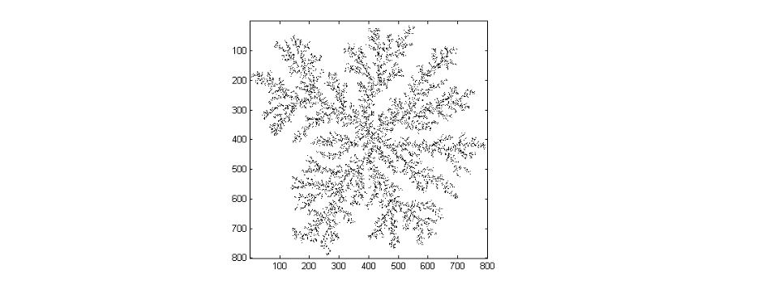Fig. 1: Image of a fractal, in this case – please use the Picture Tools facility to compress the images to 200dpi for printing, before saving. Include Scale Line value if not already embedded in the image.

|  |  |  |
| --- | --- | --- |
|  | Amount of Resources | Allocation Freedom |
| Industry | high | constrained |
| Academic | Low | unconstrained |

Table 1. Relative allocation and amount of resources in research.

**DISCUSSION AND CONCLUSIONS:** Do **NOT** tamper with the header or footer. Please submit the abstract as a Microsoft Word document. Only electronic submissions will be accepted. The submission of the abstract as a supplementary file (.DOC format) has been allowed in the step 3 of the online submission process (please refer to, http://hissl.lk/index.php/call-for-papers).

**REFERENCES:** 1 M. Ziegler (1991) *Essentials of Writing Biomedical Research Papers*, McGraw-Hill, Inc. 2 I.R. Spears, M. Pfleiderer, E. Schneider, et al (2000) *J Biomech* **33**:1471-77. 3 A.R Poole, M. Alini, and A Hollander (1995) Chondrocytes and cartilage destruction in *Mechanisms and Models in Rheumatoid Arthritis* (eds B. Henderson, J. Edwards, and R. Pettipher) Academic Press, pp 163-204.